May 15, 2026

Secretary of the Senate
Capitol Building, Rm 401
Springfield, IL 62706

Re: Personal Information Protection Act (815 ILCS 530, et seq.)
Report of a Loss of Protected Personal Information

Dear Members of the General Assembly:

Pursuant to the requirements of Section 25 of the Personal Information Protection Act, the Illinois Department of Children and Family Services (DCFS) submits this report of a breach of written material.

On May 05, 2026, a single form was inadvertently emailed to one (1) incorrect email address within the State of Illinois workforce. We identified the single form that contained the name of an individual and their medical information. The total number of individuals subject to this breach is one (1). We are reviewing the training and procedures to prevent further breaches.

DCFS sincerely regrets this incident. DCFS has contacted the affected individual and provided them with information about credit monitoring services and other ways to protect their identity.

Sincerely,

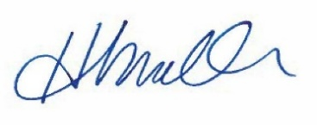

Heidi E. Mueller
Director
Illinois Department of Children and Family Services

