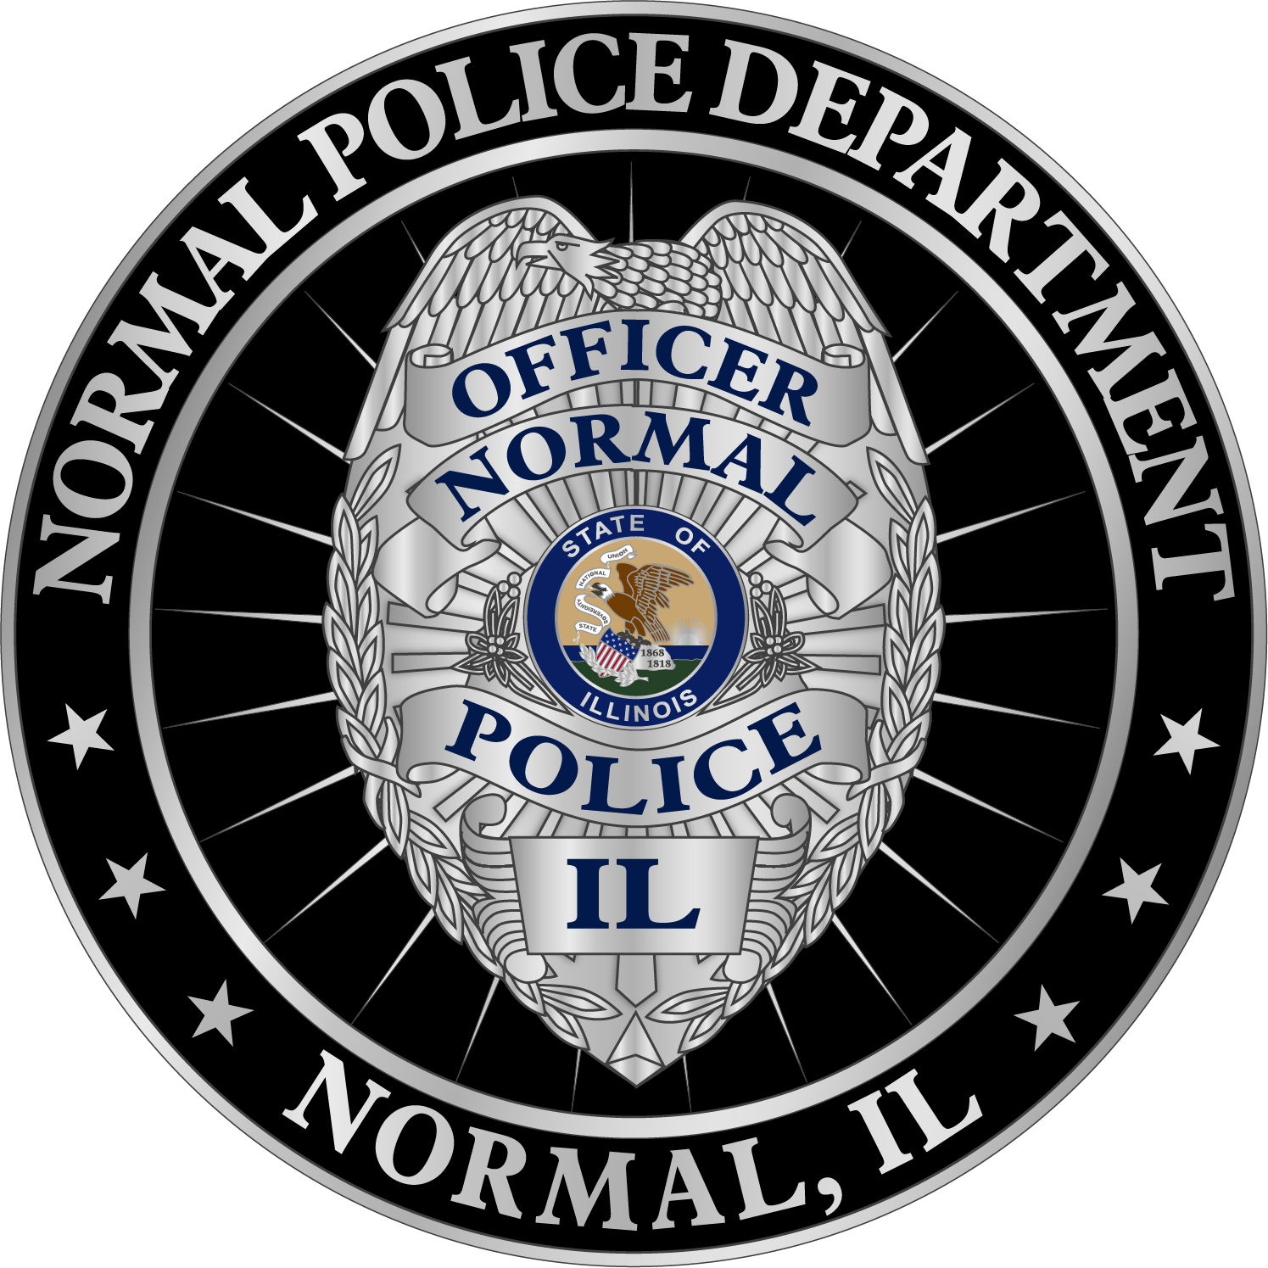
Assistant Chief
Support Services
Assistant Chief
Operations
Chief of Police
Police Service
Representative

NORMAL POLICE DEPARTMENT
Organizational Chart
February 2025

Shift Sergeants

Patrol Officers
0630-1630 Officer

Shift Sergeants

Patrol Officers

Shift Sergeants

Patrol Officers
K-9 Officer

Office Associate

Special Operations Lieutenant

Investigation Div.
Lieutenant

11-7 Shift
Lieutenant

3-11 Shift
Lieutenant

7-3 Shift
Lieutenant

TS&I
2000-0300
K-9 Officer

1800-0400
Officer

Police Service
Representative
Traffic Officers

Parking
Enforcement

Evidence /Prop.
Technicians

Crime Analyst

Community
Services Officers
Accreditation
Manager
School Resource Officers

Office Associates
Records Manager
US Marshalls
Task Force Officer

Task Force Inspectors

Intervention Specialist

Special Operations Sergeant
Task Force Field Supervisor

Investigation Unit
Sergeant

Detectives

