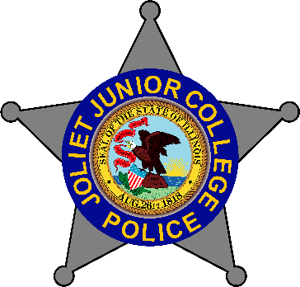
JJC POLICE DEPARTMENT
1215 Houbolt Road, Joliet, IL 60431 Chief Brandon Campbell (815) 280-6606
Ph: 815-729-9030 Fax: 815-729-9502

To: Illinois Law Enforcement Training and Standards Board 03/24/26

From: Deputy Chief Tracy Williams# 501

Subject: 2025 Annual Body Camera Report

The Joliet Junior College Police Department is comprised of 16 sworn police officers.

- Chief of Police
- Deputy Chief
- (2) Patrol Sergeant
- (1) Training Sergeant
- (1) Detective
- (11) Patrol officers one position is vacant

January of 2025 Joliet Junior College Police acquired new Panasonic body worn cameras for the first time. Prior to January in person training was conducted by the vendor. All officers successfully completed the training prior to use which included general order review of usage. During the implementation of the cameras all department owned police vehicles were retrofitted with an activation switch that will automatically activate the body camera with emergency lights are activated.

In addition to this switch all duty weapon holsters were retrofitted with a similar device which will activate the BWC when the weapon is removed from the holster.

All sworn officers were assigned individual BWC for and are currently using said camera.

Technical issues: At the onset a few accidental BWC activations occurred in the police station but later determined to be a Bluetooth connection issue, when the weapon was out of the duty holsters and inside or in the locker room. This issue has since was corrected.
During a FOIA request it was discovered that the redaction software was having an issue with processing the blurred images and refining the final video. The process was taking too long and getting stuck. The Company was contacted who provided the retention and redaction software. The company Genetec was able to locate the problem. The problem was on the back end of the company and software. Since the initial problem was discovered there have been no other issues with the camera redaction or deployment of them after an update.

Review Process: All supervisors are allowed to review BWC of those under their command at any time including complaints of policy or misconduct.

Internal complaints. The department received no internal officer complaints for 2025.

Supervisors review random samples of BWC to insure compliance with all guidelines of permitted use and proper function. The samples are documented on a department form and list any improper use and or any items that need further review. If any issues are found the supervisor meets with the officer.

Please contact me for any further questions.

Deputy Chief, Tracy Williams#501
Tracy.williams@jjc.edu
815-280-2748

