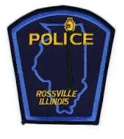
Rossville Police Department
120 E. Attica
Rossville, IL. 60963
(217) 748-6914

Lacy R Greene
Chief of Police

Camera Grant Information

04/29/2026

Rossville Police Department has 4 Sworn Full-time officers. RPD utilizes 5 body cameras and 4 Fleet cameras.
There was one incident report to Axon of Fleet camera not switching on when prompted by lightbar. This issue was resolved promptly.
The supervisor review process consists of reviewing BWC footage when citizen complaints or misconduct reports are made. When a member of the department has allegations of misconduct or abuse.

