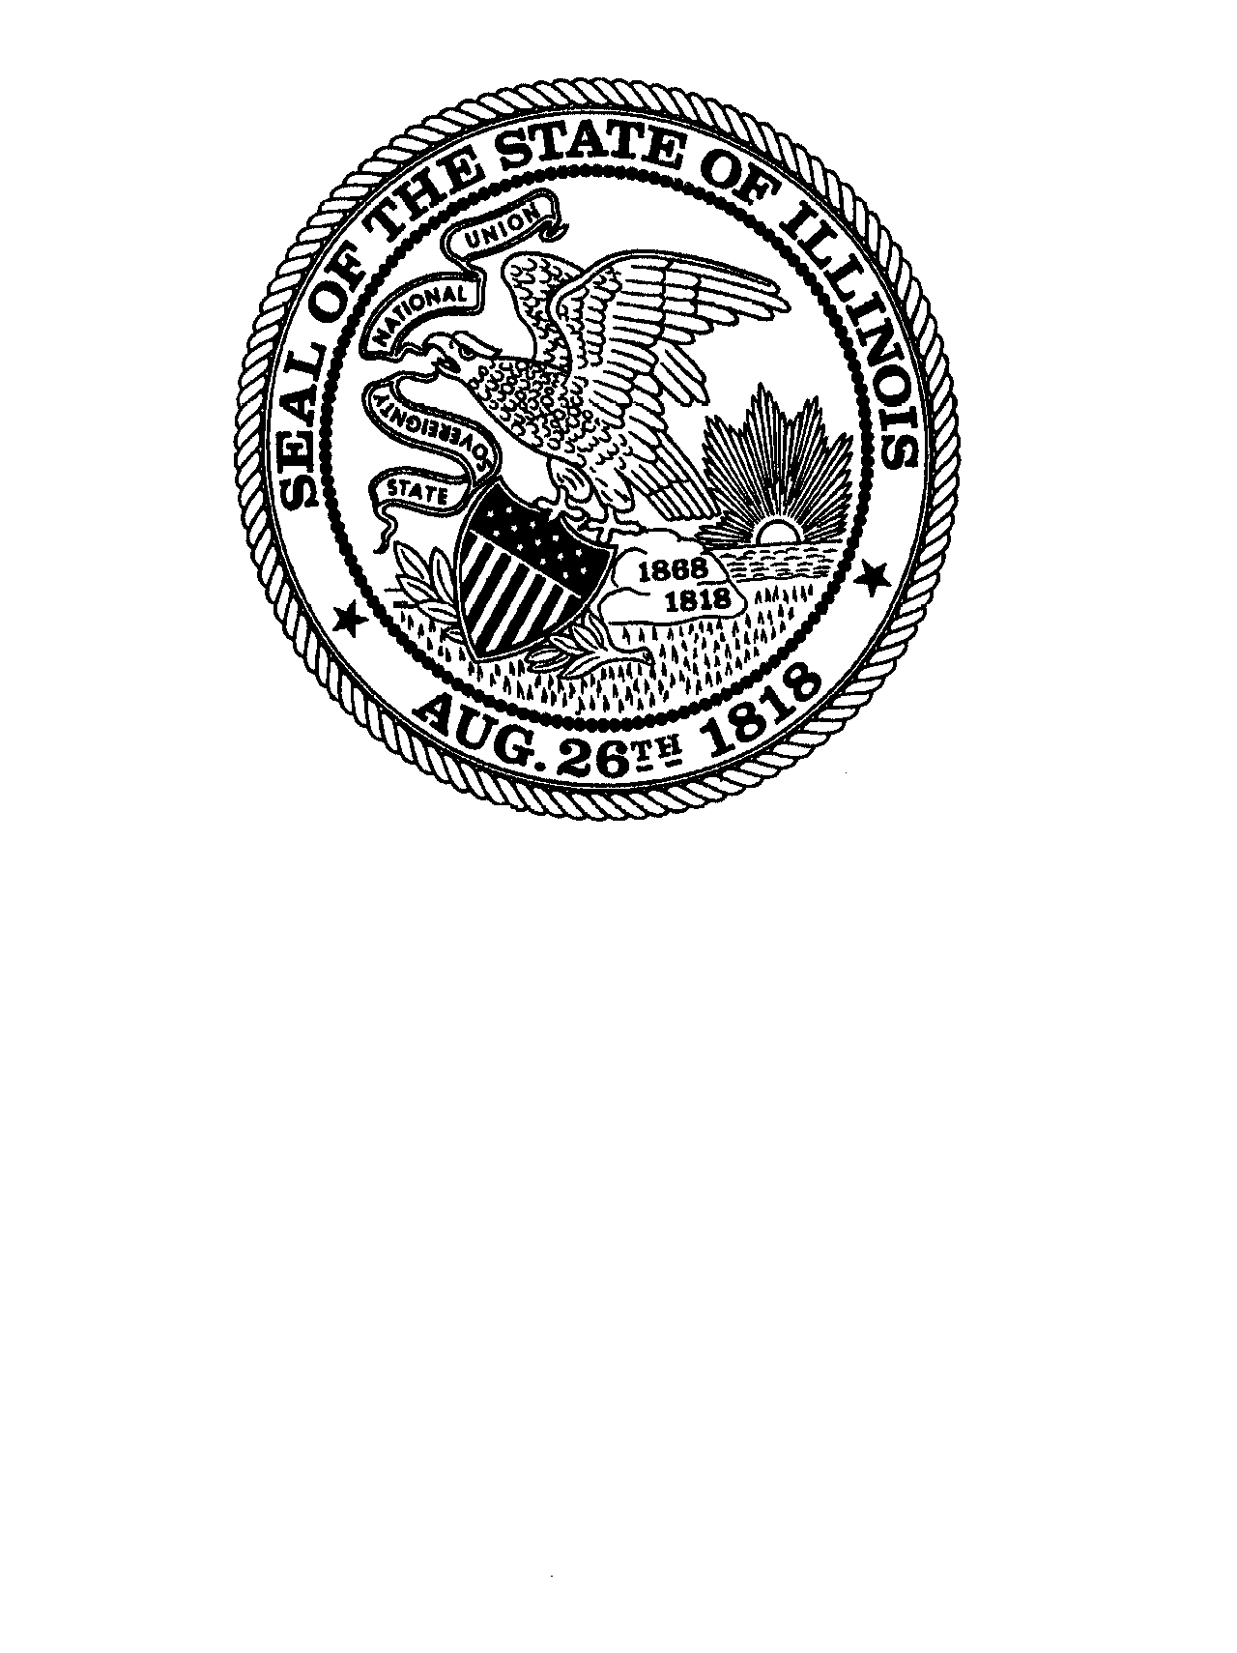
OFFICE OF THE SECRETARY OF STATE
ALEXI GIANNOULIAS Secretary of State

April 22, 2026

To the Governor of the State of Illinois, the President of the Illinois Senate, the Speaker of the Illinois House, and the Members of the Illinois General Assembly:

Report on Single-Use Plastic Disposable Foodware

The Office of the Secretary of State is providing this report in accordance with the State Entities Single-Use Plastic Reporting Act, 30 ILCS 567/10. Since July 1, 2024, the Office has purchased $1,621.43 in single-use plastic items, including cups, plates and plastic silverware. However, in its efforts to comply with the Act, the Office will continue its effort to limit the purchase and use of Single-Use Plastics.

Sincerely,

Amanda Trimmer
Chief Fiscal Officer

Katherine Tople
Chief Procurement Officer

