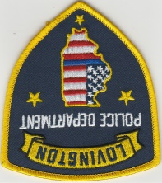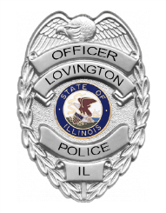

Lovington Police Department
222 South Railroad Street
Lovington, Illinois 61937-0169
Phone: (217) 972-9941 Fax: (217)-873-4481
police@lovingtonil.com
Christian L. Swisher
Chief of Police

To: Illinois Law Enforcement Training and Standards Board
Illinois Governor’s Office
Illinois General Assembly

From: Chief of Police Christian L. Swisher, Lovington Police Department

Date: 1/28/2026

Re: Annual Body Worn Camera Report (50 ILCS 706/10-1)

Please find below and attached information required by statute pertaining to Body Worn Camera use by the Lovington Police Department.

Department Makeup
The Lovington Police Department initiated a Body Worn Camera (BWC) program in May 2023. There is only one full-time officer, me, and five (5) part-time patrolmen, who have been issued/share two (2) BWC’s and are required to wear them in any law enforcement context.

Technical Issues
The department is not experiencing any specific technical issues

Review
All videos that contain any use of force are reviewed by me to ensure adherence to laws and policy. Other videos are reviewed at random or when complaints arise.

Chief Christian L. Swisher
police@lovingtonil.com
Lovington Police Department
217-972-9941

