January 22, 2026

Office of the Speaker
Illinois House of Representatives
408 State Capitol Building
Springfield, IL 62706

RE: 2025 Eavesdropping Reports

To whom it may concern:

This letter is to inform you that pursuant to 720 ILCS 5/14-3(q) requested and approved applications for the 2025 calendar year were One Hundred and Thirty (130).

Please let me know if you require anything further.

Very Truly yours,

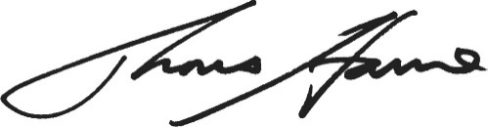
Thomas A. Haine
State’s Attorney
Madison County, Illinois

TAH/cac

cc: Matt Jones

Regards,

Thomas A. Haine
Madison County State’s Attorney

