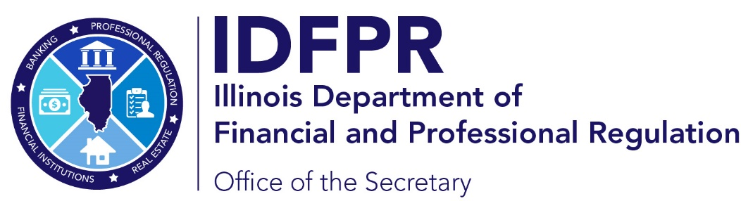 |  | idfpr.illinois.gov
JB PRITZKER  Governor |  |  | MARIO TRETO, JR.  Secretary

Pursuant to the Unified Code of Corrections at 730 ILCS 5/5-5.5-50, the Illinois Department of Financial and Professional Regulation (“IDFPR”) is to report yearly to the General Assembly the number of applicants with felony convictions who may have provided a certificate of relief from disabilities and whether the application for licensure was approved. According to the Unified Code of Corrections, the certificate is issued by courts to individuals with conviction history and creates a presumption of rehabilitation. 730 ILCS 5/5-5-5.

From December 2024 through November 2025, no certificate of relief from disabilities was received by IDFPR as part of an application for licensure. Further, IDFPR does not sort, or track conviction history disclosed in an application by type, such as felony or misdemeanor. For a full overview of the rate of acceptance and denial of applicants with conviction history, and by profession, we recommend IDFPR’s annual Safer Report (2025 Report).

Sec. 5-5.5-50. Report. The Department of Professional Regulation shall report to the General Assembly by November 30 of each year, for each occupational licensure category, the number of licensure applicants with felony convictions, the number of applicants with certificates of relief from disabilities, the number of licenses awarded to applicants with felony convictions, the number of licenses awarded to applicants with certificates of relief from disabilities, the number of applicants with felony convictions denied licenses, and the number of applicants with certificates of relief from disabilities denied licenses. 730 ILCS 5/5-5.5-50.

