
ADVANCING EXCELLENCE IN ADMINISTRATIVE ADJUDICATION

Report of the Illinois Bureau of
Administrative Hearings

Fiscal Year 2025

CONTENTS
The Illinois Bureau of Administrative Hearings (Bureau), housed within the Department of Central Management Services (CMS), presents this annual report in compliance with Executive Order 2017-04, detailing its Fiscal Year (FY) 2025 activities and key recommendations for the continued advancement of administrative justice and adjudication excellence.

- About the Bureau

- Report Highlights

- Equity and Access

- Digital Transformation

- Adjudicator Excellence

- Recommendations

ABOUT THE BUREAU: DELIVERING FAIR HEARINGS
Vision
Our vision is to deliver a convenient, simple-to-navigate forum that ensures fair resolution of contested cases, promotes access to justice, and supports innovative practices. We collaborate with state agencies, community partners, and the public to streamline processes and improve accessibility while enhancing adjudicator professional development to uphold the highest standards of fairness and expertise.
Administrative Hearings Background
An administrative hearing is a legal proceeding, held before an impartial fact finder, to review a government agency’s action. Each party to the hearing has a right to testify, present and question witnesses, and submit or challenge documents regarding the decision. The neutral fact finder, called an administrative law judge (ALJ), makes findings of fact, conclusions of law, and issues a recommended or final decision which affirms, modifies, or sets aside the government agency’s action. Hearings cover a wide range of matters, including licensing, enforcement, and appeals of agency decisions.
Organizational Structure
In 2017, the Bureau began offering voluntary adjudication services to those agencies whose caseloads did not justify operating in-house hearings units. This move allowed agencies to eliminate costs of contracting with private attorneys to serve as ALJs, ensuring cases are heard by an independent, experienced adjudicator at lower taxpayer cost. Strategic housing within CMS, an experienced agency services provider, allows the Bureau to concentrate on its mission while minimizing administrative overhead.
All Bureau proceedings are conducted by qualified ALJs who are Illinois-licensed attorneys with significant legal experience. In December, the Bureau expanded its capacity from two to six administrative law judges to meet caseload needs. The Bureau’s adjudication services range from simple administrative appeals to conducting multi-day or multiweek trial-like evidentiary hearings in complex matters. Some cases are narrow, single-issue disputes; others involve multiple complicated legal and factual disputes. Most proceedings are governed by the Illinois Administrative Procedure Act (5 ILCS 100/10/ et seq.) and the relevant statutes and rules of the agency regulatory authority under which the hearing request originated.
REPORT HIGHLIGHTS
Introduction
The Bureau plays a critical role in supporting state government agencies by offering its voluntary adjudication services to those without in-house hearings units. In doing so, the Bureau enables these agencies to concentrate fully on their primary missions without the administrative burden of managing adjudication processes internally or the fiscal burden of contracting for external support. The Bureau’s adjudicators are specially trained and experienced in administrative law procedures, providing a neutral and impartial forum for resolving disputes on regulatory and administrative matters.
More broadly, the Bureau’s mission extends beyond adjudication. We also work to strengthen the infrastructure of administrative justice – through innovation, professional development, accessibility initiatives, and stakeholder collaboration.
FY 2025 At A Glance
Fiscal Year 2025 represented a period of growth, strategic investment, and reaffirmation of core values. With increased demand from referring agencies, the Bureau expanded its bench by recruiting and onboarding four new administrative law judges, each selected for their legal acumen, impartiality, and commitment to public service. To support this growth, we also welcomed new clerical staff, whose contributions are essential to docket management, hearing preparation, and day-to-day operations.
Equity and Access
The Bureau continued to take significant steps to enhance language access and inclusivity within its hearings proceedings, underscoring the Bureau’s dedication to fostering a supportive and inclusive adjudication process that respects the dignity and rights of all persons. Emphasis was also given to developing additional resources for self-represented litigants to navigate administrative hearings without an attorney.
Digital Transformation
This fiscal year also marked the kickoff of one of the Bureau’s most anticipated initiatives: the implementation of a comprehensive electronic case management system (ECMS) and e-filing portal. This initiative represents a generational leap forward in how to process, track, and share information about administrative cases.
Adjudicator Excellence
The Bureau continued to facilitate timely learning opportunities for the state’s adjudicators at no cost to them or their employing agencies. These efforts reflect the Bureau’s dedication to maintaining high ethical standards of adjudication and fostering a culture of continuous improvement. In a meaningful new tradition, all Bureau administrative law judges affirmed a voluntary pledge of impartial service.
Key Recommendations for FY 2026
Unifying Practice and Procedure
Standardizing core administrative hearings procedures will promote consistency, reduce confusion, and support the effective implementation of electronic case management.
Launch an Adjudicator Shared Learning Platform
A centralized learning hub for adjudicators will enhance legal consistency, increase job satisfaction, and provide low to no cost professional development opportunities by tapping into the expertise of adjudicators across the state.
Strengthen Collaborative Partnerships
Stakeholders can help the Bureau identify what expectations customers want addressed, where existing systems should be made more accessible to the public, and where procedures can and should be made more user-friendly. Strengthening existing partnerships and encouraging new partnerships will lead to valuable insights.
Continue Digital Transformation
Ongoing investment in digital tools will improve access, efficiency, and coordination of administrative hearings functions, while providing a rich source of data to drive further system improvements.
Conclusion
Looking ahead, the Bureau remains firmly committed to strengthening the foundation of fairness and transparency that underpins administrative hearings. The initiatives detailed in this report demonstrate a clear path toward a more accessible, efficient, and responsive system. By advancing key recommended reforms, the Bureau will not only continue to improve how cases are managed and decided, but also build greater trust and confidence in the administrative justice process and those who rely on it.

EQUITY AND ACCESS
Removing Language Access Barriers
Essential to a fair outcome is the opportunity for meaningful participation, including the removal of language access barriers. The Bureau has maintained a robust language access plan since its inception, including trainings for its administrative law judges to identify the need for assistance and ensure a complete and accurate hearing record is made. A core priority this year was expanding access, specifically by implementing Public Act 103-1056 aimed at strengthening language help in administrative hearings.
The Bureau developed a multilingual notice informing hearings participants of their right to free interpretation services and translation support. This notice is available in 12 languages and structured as a fillable template, allowing for agency customization without duplicative drafting – offering statewide consistency while reducing administrative burden. This tool supports compliance, promotes equity, and ensures that language access is not a barrier to justice.
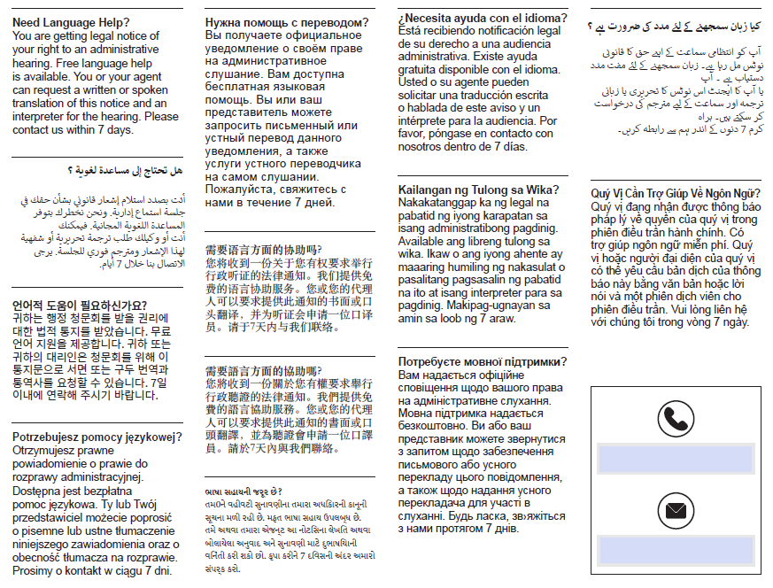
The Office of New Americans (ONA) and Language Equity and Access Partners (LEAP) consultants hosted a series of group interviews with agency Language Access Coordinators this past spring. These optional interviews aimed to gather further insights into agencies’ visions, goals, and priorities for language access implementation, and help identify priority areas that will shape ONA’s strategic planning moving forward. The Bureau was invited to participate, along with CMS’ Language Access Coordinator, given the Bureau’s largely public-facing role within CMS. By participating, the Bureau ensures that improvements in language access are based on research-supported best practices.
Expanding Resources for Self-Represented Litigants
For many litigants, appearing in an administrative proceeding is their first experience with a legal forum. Often, these individuals are self-represented, meaning they must navigate the administrative hearing process without the assistance of an attorney. To be effective, administrative law reform must consider the perspective of self-represented parties. Providing resources that support these individuals not only promotes greater access to justice but also helps reduce procedural errors and delays caused by a lack of legal understanding.
This past year, the Bureau has taken significant steps to strengthen its ongoing efforts to fill the critical need for accessible self-help support resources. This includes the development of comprehensive self-help guides written in clear, plain language to make legal concepts more accessible to non-lawyers. Through a dedicated Access to Justice internship, the Bureau will continue to develop its library of resources, including scripting and filming a series of informational videos to demystify legal procedures, empowering individuals without legal representation.
Creating an Access to Justice Internship
In support of its ongoing commitment to making the legal and administrative processes more accessible and user-friendly, the Bureau developed its first year-long Access to Justice internship. Established within the Graduate Public Service Intern (GPSI) program of the University of Illinois- Springfield, the intern will contribute to policy research, data analysis, and process improvement efforts surrounding access to justice. The program offers an opportunity for the intern to engage in projects that enhance accessibility, procedural fairness, and public understanding about the administrative hearing process.
The first intern is set to begin in September, and will support a range of initiatives, including language access, outreach, and user-centered process improvements. This is more than an internship – it is a pipeline for mentorship and professional growth, inviting emerging leaders to explore careers in administrative law and public service.
DIGITAL TRANSFORMATION
A Milestone in Modernization
This year marked a major milestone in the Bureau’s long-term strategic modernization efforts: kickoff to implementation of a comprehensive electronic case management system (ECMS) and secure e-filing portal. One of the Bureau’s most anticipated initiatives, this digital transformation aims to modernize how cases are received, managed, and resolved. This project reflects years of planning and collaboration with stakeholders, and it lays the foundation for a more seamless, transparent, and responsive hearing system for agencies, participants, and the Bureau itself.
Improving Operational Efficiency
This new platform is being designed to replace fragmented, manual processes with integrated digital workflows. Case intake will be faster and more accurate, document management centralized, and scheduling tools will allow staff to better track deadlines and manage workloads. A fully implemented system is expected to bring savings through the elimination of cumbersome paper-based processes and the tedious hours spent supporting them, including an estimated 50% reduction in time spent on calls, emails, and faxes; 45% reduction in first class mailings; 55% reduction in time spent scheduling; 70% reduction in time spent creating the administrative review record and 55% reduction in time spent creating reports.
Moreover, a fully implemented case management system will enable real-time data. For referring agencies, this means they can track the status of hearing referrals, coordinate more easily with staff for internal review, and have greater visibility into the lifecycle of a case. Within the Bureau, staff will have real-time dashboards to monitor caseloads, identify bottlenecks, and forecast staffing needs based on incoming case volume.
Enhancing the Hearing Experience
For participants, the user portal will offer an easier and more transparent way to engage in the hearing process. Individuals can file documents securely online, access notices and case materials at any time, and receive automatic updates about their case. For self-represented litigants in particular, this transformation is significant. It reduces the complexity of filing, avoids delays related to physical mail or travel, and ensures timely access to information. The system will use step-by-step prompts, validation checks, and built-in logic to ensure all required information and documents are submitted completely and accurately the first time, reducing delays and administrative burden.
ADJUDICATOR EXCELLENCE
Since its inception, the Bureau has facilitated more than 5,000 person-hours of adjudicator-focused learning and provided tangible resources such as a convenient bench book. This year, the Bureau deepened its investment in learning through training collaborations, peer-led initiatives, and comprehensive onboarding for new adjudicators.
Training Collaborations
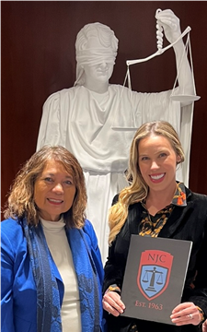
In October, Bureau staff attended the National Association of Administrative Law Judiciary (NAALJ) Conference in Chicago. The conference provided a vital platform for engaging with adjudicators across the nation, sharing strategies for improving the quality and accessibility of administrative hearings.
In November, our central panel colleagues at Cook County’s Department of Administrative Hearings generously invited the state’s adjudicators to participate in an Administrative Law Essentials course designed by the National Judicial College and held at the American Bar Association in Chicago. The Bureau facilitated the participation of 20+ adjudicators from ten State of Illinois agencies, at no cost to the employing agency.
Participants discussed and shared best practices about effectively managing exhibits and safeguarding the integrity of evidence; hearing room security; adjudicator ethics and standards of conduct; the impact of culture, bias, and privilege on procedural fairness; and effective decision-making.
Throughout the year, the Bureau’s administrative law judges participated in webinars and virtual trainings hosted by both the National Judicial College and the National Association of Hearing Officials (NAHO). These courses not only sharpen expertise, but also reflect continuous learning as a core value.
Peer-Led Learning and Internal Innovation
Within the Bureau, we launched a series of roundtables – confidential peer-led discussions where administrative law judges reviewed challenging case scenarios, discussed evolving legal doctrines, and shared insights across program areas. These forums created space for reflection and community, especially important in a central panel model that spans multiple agency subject matters.
As an outcome of these roundtables, the Bureau’s administrative law judges began developing case-type specific toolkits – concise, quick reference guides that will inform future internal training sessions. Moreover, procedural citations from these toolkits will be incorporated into the Bureau’s new electronic case management system, enhancing data capture and refining how various case types are tracked and distinguished.
Building a Strong Foundation
The Bureau continued to demonstrate its commitment to excellence in adjudication by supporting the development of newly onboarded administrative law judges.
In November, the Bureau was again invited to present on the topics of Due Process and Foundations of Administrative Law at a mandated training for new municipal hearing officers coordinated by the Illinois Local Government Lawyer’s Association and the Cook County Department of Administrative Hearings.
Following the hiring of four new administrative law judges in December, the Bureau implemented its own robust onboarding and training process. Each new hire completed an intensive four-week course through the National Judicial College - Taking the Bench: An Interactive, Online Course for New Administrative Law Judges. This highly interactive course was facilitated using discussion and writing assignments, readings, videos, and weekly live webinars with faculty. This formal training was supplemented by internal training on the specific case types handled by the Bureau.
In a meaningful new tradition, all Bureau administrative law judges affirmed a voluntary pledge of impartial service. This symbolic pledge represents a collective reaffirmation of the duty to provide fair, unbiased hearings. The ceremony included continuing education from a state appellate justice, who shared valuable insights on writing clear, legally sound decisions. This ceremonial affirmation will now be incorporated into future onboarding cycles, reinforcing the ethical foundations of the Bureau’s work.


RECOMMENDATIONS
To advance fairness, consistency, and efficiency in the state’s administrative hearings system, the Bureau has identified several key recommendations for reform:
Unify Practice and Procedure
Standardizing core elements – such as notice requirements, evidentiary rules, and hearing formats – would reduce confusion for the public, simplify training for adjudicators, and ensure a more transparent process regardless of the originating agency or subject matter. The ongoing process of configuring the Bureau’s new case management system has underscored the urgency of this need. The Bureau looks forward to working collaboratively with all stakeholders to move toward greater procedural standardization, balancing flexibility with fairness and clarity.
Launch an Adjudicator Shared Learning Platform
Developing a centralized, digital platform where adjudicators can access shared resources would promote professional development, support consistent application of legal principles, and foster a stronger, more connected adjudicator community across agencies. By leveraging the collective expertise of adjudicators statewide, high quality content can be developed at little to no cost. In addition to supporting performance, such a platform would increase job satisfaction by encouraging collaboration.
Strengthen Collaborative Partnerships
Since its inception, the Bureau has built and continues to grow partnerships with both internal and external stakeholders to effectuate largescale improvement efforts. Stakeholders can help the Bureau identify what expectations customers want addressed, where existing systems should be made more accessible to the public, and where procedures can and should be made more user-friendly. Continuing to increase stakeholder participation will afford the Bureau expanded capacity and perspective.
Continue Digital Transformation Efforts
Continued development should focus on expanding system functionality, integrating user-centered design features, and configuration for additional legal process use. Advancing this work will improve service delivery, reduce administrative burden, and enhance public access to justice – laying the groundwork for a more modern, data-informed, and responsive administrative adjudication system.

Contact Us:
Telephone: (217) 558-1060
Email: AdministrativeHearings@illinois.gov
Main Office Location: Chicago Location:
401 S. Spring Street, Suite 502 555 W. Monroe Street, 13th Floor
Springfield, Illinois 62706 Chicago, Illinois 60661

