State of Illinois
J.B. Pritzker, Governor

Illinois Department of Natural Resources

Open Space Lands Acquisition
And Development Grant Program

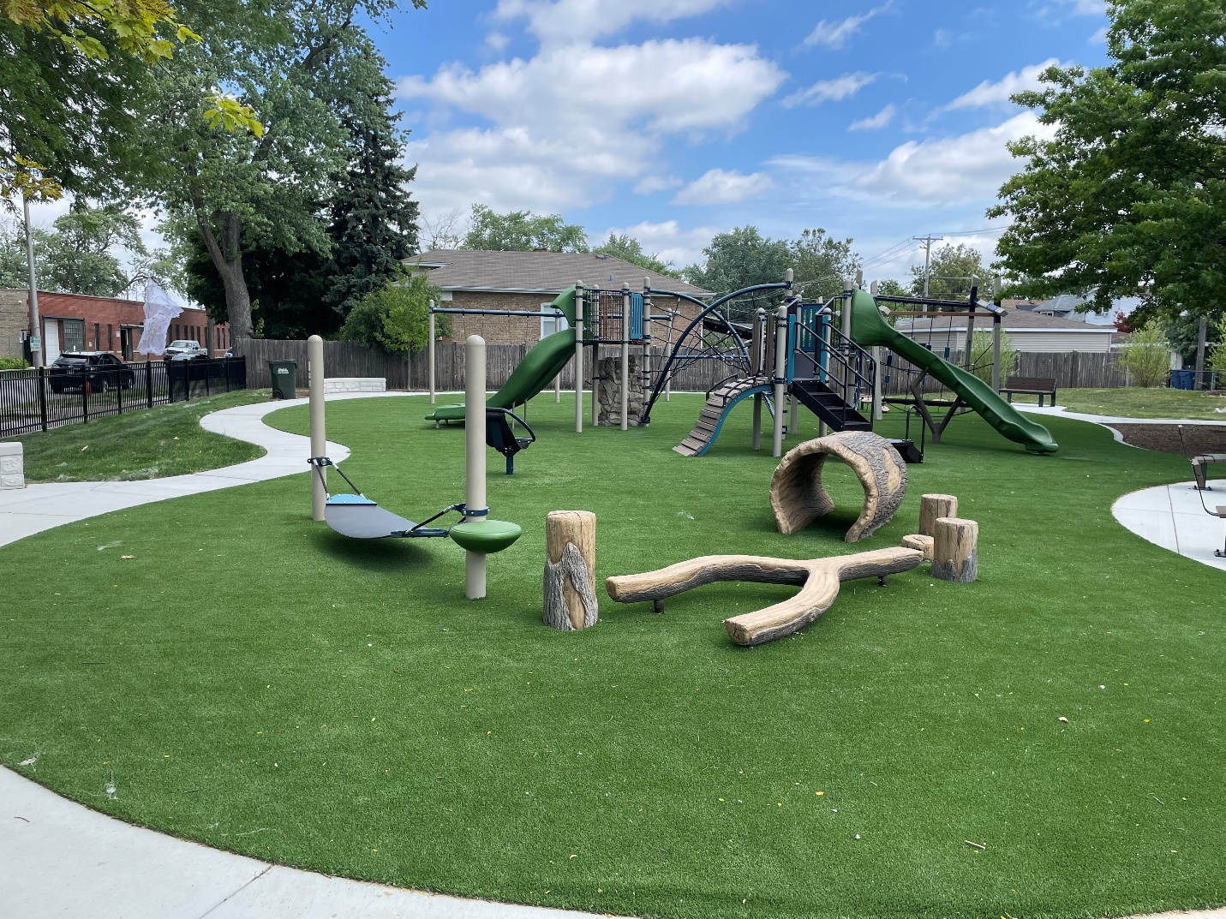

OSLAD
ANNUAL REPORT
Fiscal Year 2025

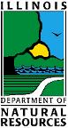
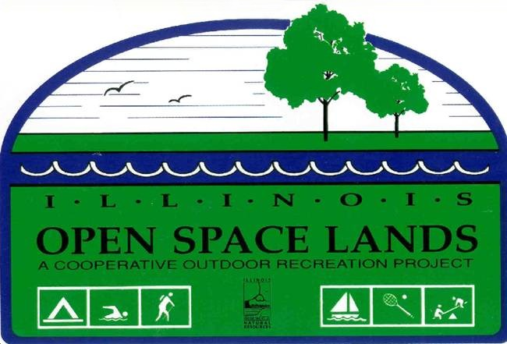



Dear Governor Pritzker and members of the Illinois General Assembly:

The Illinois Department of Natural Resources (IDNR) is pleased to present the Open Space Lands Acquisition and Development (OSLAD) grant program’s annual report for fiscal year 2025.

The OSLAD program is one of IDNR’s most popular grant programs. With continued support by the legislature, OSLAD received $54 million of funds in FY25 for acquisition and development of recreation projects in Illinois. This program has become a vital resource for local agencies as they try to keep pace with the growing demands for additional open space land and new outdoor recreation opportunities while rehabilitating aging recreation facilities.

The OSLAD program has enabled local governments, individually and cooperatively, to commit to large-scale, long-term recreation, and open space and natural resource preservation initiatives, often transcending jurisdictional boundaries. As such, the OSLAD program not only forges state-local partnerships but also helps foster local, intergovernmental partnerships.

Your support and expansion of the OSLAD program has improved the quality of life in many Illinois communities by providing public recreation, securing perpetual open space for future generations, and increasing the benefits on citizens’ health through exercise. IDNR is committed to the continued administration of this program in a manner responsive to the changing outdoor recreational needs of local governments throughout the state.

Sincerely,

Natalie Phelps Finnie
Director

Table of Contents

A Brief History of the Illinois Open Space Lands Acquisition Program 2

Project Selection

Program Mechanics 2

Program Priorities 3

Application Evaluation 3

Grant Awards for 2025 4

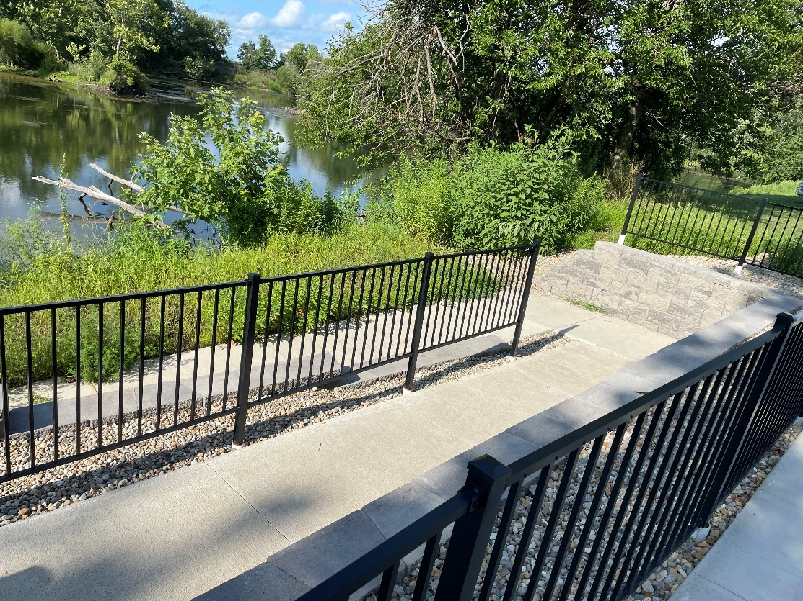

Equal opportunity to participate in programs of the Illinois Department of Natural Resources (IDNR) and those funded by the U.S. Fish and Wildlife Service and other agencies is available to all individuals regardless of race, sex, national origin, disability, age, religion or other non-merit factors. If you believe you have been discriminated against, contact the funding source’s civil rights office and/or the Equal Employment Opportunity Office, IDNR, One Natural Resources Way, Springfield, ILL. 62702-1271; (217) 785-0067; TTY (217) 782-9175. The funding source for the LWCF program is the U.S. Department of the Interior, National Park Service. The address for the civil rights office is: Equal Opportunity Program Director, U.S. Department of the Interior, National Park Service, P.O. Box 37127, Washington, DC 20013-7127.

A BRIEF HISTORY OF THE ILLINOIS OPEN SPACE LANDS ACQUISITION & DEVELOPMENT PROGRAM

In response to dwindling federal dollars throughout the 1980s and early 1990s for Illinois’ growing outdoor recreation demands, the Illinois General Assembly established the Open Space Lands Acquisition and Development (OSLAD) program in fiscal year 1986 as part of the Build Illinois Bond fund initiative. The legislation authorized $40 million over a five-year period beginning in FY-86. However, during that five-year period only $22.6 million was appropriated and expended.

To help ensure more predictable and stable program funding, Senate Bill 1463 was passed and signed into law in 1990 as P.A. 86-466, dedicating a portion of the revenues derived from the state’s Real Estate Transfer Tax specifically for the OSLAD program. Allocation of funds from this dedicated source was phased in over a five-year period beginning in FY91.

With full funding achieved in FY95, 35% of the revenue derived from the Real Estate Transfer Tax was allocated annually to the OSLAD program. This translated into an annual program appropriation level of between $17 million and $29 million, but the program always depended on the vitality of the real estate market in Illinois.

PROGRAM MECHANICS

The OSLAD program is administered by the Illinois Department of Natural Resources (IDNR), acting under authority of 525 ILCS 35, Administrative Code Title 17: Chapter I, Subchapter g, Part 3025, and annual appropriation statutes. Through the OSLAD program, IDNR provides grants to eligible local governments on a 50/50 cost-sharing basis (90/10 for “distressed” local governments) for approved park, open space, and conservation land acquisition and capital development projects. Examples of eligible projects include acquisition of land for new or expanded park areas, preservation of pristine natural areas, and construction or renovation of outdoor recreation facilities such as picnic areas, playfields and courts, playgrounds, swimming pools and other water recreation facilities, campgrounds, trails, nature centers, and winter recreation facilities.

All local units of government having statutory authority to provide public park facilities, such as municipalities, counties, parks, forest preserves, and conservation districts, are eligible to apply. Grants are awarded on a competitive basis based upon online applications submitted to IDNR by the published application deadline date.

Applications for grant assistance were accepted by IDNR between July 1, 2024, and September 13, 2024. Department staff objectively evaluated and prioritized each proposal according to a numeric scoring instrument. The project evaluation instrument is designed to make project selection equitable and responsive to statewide and local outdoor recreation needs and program objectives that are published in the local participation grant manual provided to all applicants. Priorities for OSLAD funding are outlined in the next section.

IDNR staff visit the proposed sites as part of the review, scoring, and evaluation process. After review and deliberations, final recommendations are made to the director of IDNR for project approval. Grant awards are typically announced within a year.

In FY25, the legislature approved the funds available for OSLAD to $54 million. IDNR also made the decision to continue the increase of the funds available to grant awards at $3,252,650 for land acquisition and $52,511,605 for development (construction) projects. Local governments are limited to one acquisition and one development project application per year.

After grant award approval, 50% of the grant award may be paid to the local sponsors after the grant agreement is fully executed. The remainder of the grant will be paid to the local sponsors as matching funds are expended. Final grant reimbursement (payment) is made upon satisfactory project completion. Normally, one year is given to complete an acquisition project and two construction seasons for development projects.

To ensure continuing project accountability, IDNR monitors all completed acquisition projects in perpetuity by either conducting on-site inspections at five-year intervals or by requesting written reports from local sponsors certifying continuing compliance with program regulations. Sites receiving only OSLAD development grant assistance are bound by the OSLAD outdoor recreation use requirements for a specified period up to 20 years depending on the amount of OSLAD funds expended on the project.

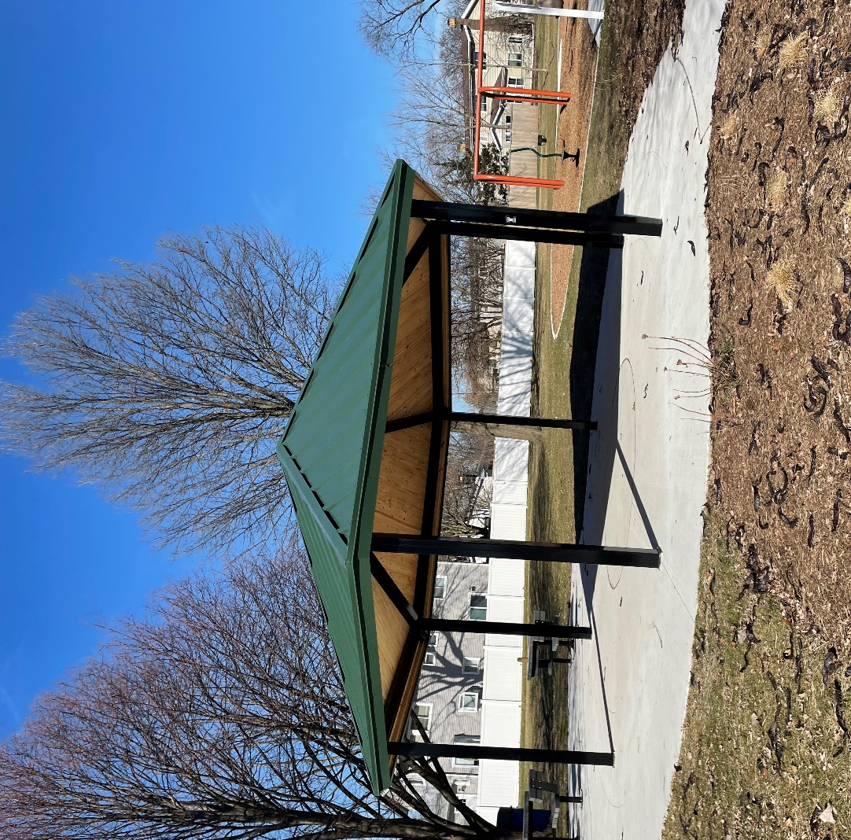

PROGRAM PRIORITIES

As stipulated in the OSLAD Act, priorities for grant allocations are given to projects that:

- Provide the greatest benefit to the residents of the areas of the State that have the highest concentration or density of population; and/or
- Are based on criteria established by the Department that reflect outdoor recreation needs and priorities identified through the State Comprehensive Outdoor Recreation Plan (SCORP)

APPLICATION EVALUATION

An objective application evaluation instrument has been developed based on the above program priorities and regularly updated to reflect current priorities outlined in the Department’s comprehensive five-year outdoor recreation plan and various other planning efforts.

Application for funding assistance will not be considered by the Department if:

- An unresolved program violation exists relative to a previous grant project or;

GRANT AWARDS

The Office of Grant Management and Assistance (OGMA) received 200 applications. Six were not qualified according to the Grant Accountability and Transparency Act (GATA). All qualified applications were given an eligibility review for application completeness. Seventy-four applicants were determined to be ineligible or withdrew. Eligible applicants were reviewed and scored based on criteria that was outlined in the Notice of Funding Opportunity (NOFO).

The following list of grants were funded with FY25 funds. Available program funds allowed IDNR to fund and award 100 projects totaling $55,574,329. Twenty-nine Distressed Communities were recommended for $17,362,750, which makes up 32% of all recommended funding.

Grantee | Project Name | County | Congressional District | Senate District | House District |  | Grant Award
FY25 Funds
Arlington Heights Park District | Centennial Park | Cook | 9 | 27 | 54 | $ | 600,000
Berwyn Park District | Proksa Park | Cook | 4 | 11 | 21 | $ | 600,000
Blandinsville-Hire Park District | Blandinsville Park Improvements | McDonough | 15 | 47 | 103 | $ | 600,000
Broadview Park District | Schroeder Park Pool Safety Compliance and Splash Pad Renovation | Cook | 7 | 4 | 7 | $ | 600,000
Burr Ridge Park District | Harvester Park Recreation and Interpretive Improvements | DuPage | 6 | 41 | 82 | $ | 425,100
Campton Township | Anderson Park | Kane | 11 | 33 | 65 | $ | 600,000
Carol Stream Park District | Pleasant Hill Park | DuPage | 6 | 23 | 45 | $ | 600,000
Champaign County Forest Preserve District | Reclamation for Expanded Conservation and Water Recreation at River Bend | Champaign | 15 | 101 | 51 | $ | 1,125,000
Champaign Park District | All Abilities Activity Hub | Champaign | 15 | 52 | 103 | $ | 600,000
Chicago Park District | Moran Park Redevelopment | Cook | 7 | 3 | 6 | $ | 1,000,000
City of Bloomington | Sunnyside Park Sustainability Initiative | McLean | 17 | 46 | 91 | $ | 600,000
City of Charleston | Linder Sports Complex Pickleball Facility | Coles | 15 | 51 | 101 | $ | 600,000
City of Danville | Garfield Park Revitalization | Vermilion | 15 | 52 | 104 | $ | 600,000
City of Elgin | Wing Park | Kane | 8 | 22 | 43 | $ | 600,000
City of Evanston | James Park Renovations | Cook | 9 | 9 | 18 | $ | 600,000
City of Golconda | Downtown Park | Pope | 112 | 59 | 117 | $ | 600,000
City of Mendota | City of Mendota's Strouss Park Project | LaSalle | 14 | 37 | 74 | $ | 600,000
City of Morrison | Morrison Sports Complex Project | Whiteside | 17 | 49 | 74 | $ | 81,500
City of Ottawa | Ottawa Community Park Land Acquisition | LaSalle | 14 | 38 | 76 | $ | 636,450
City of Spring Valley | City of Spring Valley Baseball Park | Bureau | 14 | 38 | 76 | $ | 600,000
City of Watseka | City of Watseka Lakeview Park Improvements | Iroquois | 2 | 53 | 106 | $ | 597,625
City of Woodstock | Water Works Splash Pad Development | McHenry | 11 | 32 | 63 | $ | 600,000
Darien Park District | Westwood Park Redevelopment | DuPage | 6 | 41 | 82 | $ | 600,000
Grantee | Project Name | County | House District | Senate District | Congressional District |  | Grant Award
Decatur Park District | Garfield Park Phase II Improvements Project | Macon | 13 | 48 | 96 | $ | 400,000
DeKalb Park District | League of Women Voters Park | DeKalb | 14 | 38 | 76 | $ | 600,000
Downers Grove Park District | McCollum Park | DuPage | 6 | 41 | 81 | $ | 600,000
Fon du Lac Park District | Neumann Park Improvements | Tazewell | 16 | 46 | 91 | $ | 600,000
Forest Preserve District of Cook County | Acquisition of Sauk Village Habitat Connector Parcel | Cook | 2 | 17 | 34 | $ | 1,067,500
Forest Preserve District of DuPage County | Greene Valley Forest Preserve Outdoor Recreational Improvements | DuPage | 11 | 41 | 81 | $ | 600,000
Geneva Park District | Winding Creek | Kane | 11 | 42 | 83 | $ | 600,000
Glencoe Park District | West Park | DuPage | 10 | 29 | 57 | $ | 600,000
Griggsville Community Park District | Griggsville Community Park District Park Improvements Project | Pike | 15 | 50 | 100 | $ | 600,000
Hanover Township | William Tiknis Campus Reserve | Jo Daviess | 3 | 25 | 49 | $ | 600,000
Homewood-Flossmoor Park District | Irwin Park | DuPage | 12 | 15 | 30 | $ | 600,000
Huntley Park District | Ol' Timers Park | McHenry | 11 | 35 | 69 | $ | 384,500
Itasca Park District | Itasca Springbrook Nature Center Improvements | DuPage | 8 | 24 | 48 | $ | 600,000
Lake Bluff Park District | Knollwood Park | Lake | 10 | 29 & 30 | 58 & 60 | $ | 293,300
Martinsville, City of | Martinsville Recreational Improvement Project | Clark | 12 | 51 | 102 | $ | 600,000
Midlothian Park District | Memorial Park Renovation | Cook | 1 | 15 | 30 | $ | 400,000
Morton Grove Park District | National Park | Cook | 9 | 8 | 15 | $ | 600,000
Mundelein Park and Recreation District | Keith Mione Community Park | Lake | 10 | 30 | 59 | $ | 600,000
Murphysboro Park District | Bocce Court Expansion | Jackson | 12 | 58 | 12 | $ | 149,574.32
Northbrook Park District | West Park Renovation | Cook | 10 | 29 | 57 | $ | 600,000
New Lenox Community Park District | Sharon’s Bay Park Redevelopment | Will | 1 | 19 | 37 | $ | 600,000
Oak Lawn Park District | Lakeshore Park | Cook | 3 | 18 | 36 | $ | 600,000
Grantee | Project Name | County | Congressional District | Senate District | House District |  | Grant Award
Ohio, Village of | Memorial Park OSLAD Development Project | Bureau | 16 | 37 | 73 | $ | 600,000
Park District of Franklin Park | Garden Park Acquisition | Cook | 4 | 10 | 20 | $ | 255,200
Park District of La Grange | Gilbert Park Renovations | Cook | 4 | 4 | 8 | $ | 600,000
Park District of Oak Park | Longfellow Park Redevelopment | Cook | 7 | 39 | 78 | $ | 600,000
Plainfield Park District | Creekside Crossing South Park Development | Will | 14 |  |  | $ | 260,000
Pleasure Driveway Park District of Peoria | Markwoodlands Park Improvements | Peoria | 17 | 37 | 92 | $ | 600,000
Princeton Park District | Zearing Park Playground Project | Bureau | 74 | 37 | 16 | $ | 216,000
River Trails Park District | Tamarack Trails Park | Cook | 9 | 29 | 57 | $ | 379,100
Rockford Park District | Harkins Pool Improvements | Winnebago | 17 | 34 | 17 | $ | 600,000
Roselle Park District | Kemmerling Park | DuPage | 8 | 24 | 48 | $ | 600,000
Shabbona, Village of | Purdy Park Improvements | DeKalb | 14 | 37 | 74 | $ | 224,040
Springfield Park District | Lincoln Park Re-Development | Sangamon | 13 & 18 | 44 | 99 | $ | 600,000
St. Charles Park District | Harvest Hills Park | Kane | 11 | 42 | 83 | $ | 600,000
Sterling Park District | Thomas Park Development Project | Whiteside | 17 | 47 | 74 | $ | 600,000
Streamwood Park District | Hoosier Grove Park Improvements | Cook | 8 | 2225 | 4443 | $ | 600,000
The Village of Riverton | Field of Dreams Park Extension | Sangamon | 15 | 54 | 108 | $ | 600,000
Vernon Hills Park District | Grosse Pointe Park | Lake | 10 | 30 | 59 | $ | 600,000
Village of Antioch | Centennial Park Master Plan Phase I | Lake | 10 | 32 | 64 | $ | 600,000
Village of Ashton | Splash Pad Reconstruction | Lee | 14 | 45 | 90 | $ | 163,175
Village of Bellmont | Bellmont Park Rehabilitation | Wabash | 12 | 58 | 116 | $ | 600,000
Village of Bluford | Bluford Village Park | Jefferson | 12 | 58 | 116 | $ | 600,000
Village of Bradford | Elsie Drawyer Hodges Park Revitalization | Stark | 16 | 37 | 73 | $ | 600,000
Village of Brookfield | Creekside Park Revitalization | Cook | 4 | 1 | 2 | $ | 600,000
Village of Cullom | Village Park Improvements - Phase I | Livingston | 16 | 53 | 106 | $ | 600,000
Village of Davis | Memory Park Improvements Project | Stephenson | 16 | 45 | 90 | $ | 302,265
Grantee | Project Name | County | House District | Senate District | Congressional District |  | Grant Award
Village of Elmwood Park | Conti Circle Pickleball and Park Improvements | Park | 3 | 39 | 77 | $ | 376,250
Village of Fox Lake | Lakefront Open Space Development | McHenry | 10 | 32 | 64 | $ | 600,000
Village of Fox River Grove | Lions Park Improvements | McHenry | 9 | 26 | 52 | $ | 600,000
Village of Glen Carbon | Schon Park Improvements, Phase 3 | Madison | 13 | 56 | 112 | $ | 600,000
Village of Glendale Heights | Simons Property | DuPage | 8 | 23 | 46 | $ | 600,000
Village of Grand Ridge | Village of Grand Ridge Park OSLAD | LaSalle | 16 | 38 | 76 | $ | 300,000
Village of Grant Park | Hilgert Park Improvements | Kankakee | 2 | 17 | 34 | $ | 300,000
Village of Hamburg | Hamburg Mississippi Access &amp; Recreation Park | Calhoun | 100 | 50 | 15 | $ | 599,150
Village of Hamel | Hamel Heroes Park | Madison | 15 | 55 | 109 | $ | 600,000
Village of Irving | Village of Irving Park Renovations | Montgomery | 15 | 54 | 5 | $ | 600,000
Village of Lee | Gordy Korth Park Upgrades | Lee, DeKalb | 14 | 37 | 74 | $ | 600,000
Village of Lemont | Heritage Quarries & Canal Trail Amenity Improvements | Cook, DuPage, Will | 1 & 11 | 41 | 82 | $ | 600,000
Village of Lincolnwood | Henry A. Proesel Park | Cook | 9 | 8 | 16 | $ | 600,000
Village of Loami | Colburn Park Improvements | Sangamon | 15 | 54 | 108 | $ | 600,000
Village of London Mills | Village Park Improvements | Fulton | 17 | 47 | 94 | $ | 600,000
Village of Maquon | Maquon Village Park Improvements | Knox | 17 | 47 | 93 | $ | 587,700
Village of Matteson | Caboose Park Phase 1 | Cook | 2 | 19 | 38 | $ | 600,000
Village of New Haven | Village of New Haven Park | Gallatin | 12 | 59 | 117 | $ | 482,400
Village of Orland Park | Schussler Park ADA Playground Development | Cook | 6 | 18 | 35 | $ | 600,000
Village of Sheffield | Sheffield All Seasons School Park Expansion Phase 1 | Bureau | 16 | 37 | 73 | $ | 600,000
Village of South Elgin | Ralph E. Tredup Park Redevelopment | Kane | 8 | 33 | 65 | $ | 600,000
Village of Sparland | Village of Sparland Frank park OSLAD | Marshall | 16 | 53 | 105 | $ | 600,000
Village of Spring Bay | Spring Bay Marina Acquisition | Woodford | 16 | 37 | 73 | $ | 168,500
Village of Willowbrook | Borse Memorial Community Park Phase 3 | DuPage | 6 | 41 | 82 | $ | 600,000
Village of Winfield | Riverwalk Park Phase Three | DuPage | 6 | 21 | 42 | $ | 600,000
Grantee | Project Name | County | House District | Senate District | Congressional District |  | Grant Award
Warrenville, City of | Cerny Park Improvement Project, Phase 2 | DuPage | 11 | 24 | 47 | $ | 600,000
Wauconda Park District | Wauconda (Bangs Lake) Marina | Lake | 11 | 26 | 52 | $ | 600,000
Waukegan Park District | Roosevelt Park Renovation and Accessible Playground | Lake | 10 | 30 | 60 | $ | 600,000
Wilmette Park District | Hibbard Park | Cook | 9 | 9 | 17 | $ | 600,000
Worth Park District | Stahlak Park Improvements | Cook | 6 | 18 | 35 | $ | 600,000

