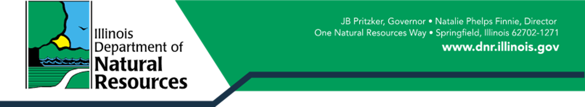

REPORT TO THE GENERAL ASSEMBLY

on the

ILLINOIS FOREST DEVELOPMENT FUND
2024

Background / Introduction

This Report is submitted by the IDNR Forestry Division, pursuant to the following requirement in the Illinois Forestry Development Act (525 ILCS 15/5):

Starting in 2025, the Department shall file a report in writing to the General Assembly on or before March 1 of each year with the following information from the preceding year: the total number of agreements entered into pursuant to this Section, the total amount of payments made pursuant to this Section from the Illinois Forestry Development Fund, and the total number of acres that were affected by the payments.

The Forestry Development Act (FDA), passed in 1983, laid a foundation for the management of forests on private land. The FDA created a tax incentive for forest landowners who make a long-term investment in their forestland through a forest management program. Additionally, the FDA created: (1) the Illinois Forestry Development Council, (2) the Forestry Development Cost Share Program, and (3) the Forestry Development Fund. The FDA is directly connected to the Timber Buyers License Act (225 ILCS 735/), which requires the collection of a 4% harvest fee, which is specifically directed to be expended for the purposes of accomplishing the FDA (225 ILCS 735/9a):

(f) The fees required by this Section shall be deposited in the Illinois Forestry Development Fund, a special fund in the State treasury, for the purposes of the Illinois Forestry Development Act.

The five purposes of the FDA are specifically listed in Act (525 ILCS 15/7) as follows:

- implementation of acceptable forest management practices through a Cost-Share Program
  - Section 4(a) of the Act also specifies the FDA Cost-Share Program created in Section 5 be implemented in coordination with the USDA Natural Resources Conservation Service (NRCS) and the Farm Service Agency (FSA). This is an important component of the FDA Cost-Share Program, as this language clearly links the FDA Cost-Share Program (state-funds), to USDA Cost-Share programs (federal-funds), for accomplishing the purposes of the FDA.

- provide assistance and pay expenses of the Illinois Forestry Development Council,
  - Section 4(c) specifies the IDNR will provide assistance to the Council, and Section 5 specifies the IDNR may categorize forest management practices and determine appropriate cost-share percentages upon recommendations from the Council.
- ordinary operating expenses of the Forest Resources Division for the administration and implementation of the Forest Development Act,
  - Section 4(b) and Section 5 specifically state the IDNR’s responsibilities under the Act include reviewing, revising, and approving Forest Management Plans as required by the Act, and also periodically evaluating Forest Management Plans of FDA participants for compliance with program requirements.
- the development and implementation of wood industry marketing program,
  - Section 4(d) states IDNR shall promote an active forest industry in the state by providing information to timber growers related to acceptable management practices, marketing information, availability of federal assistance, soil and water conservation benefits, and wildlife habitat enhancement.
(5) other programs beneficial to advancing forests and forestry in the state.

This Report is organized to correspond to the five purposes on the FDA listed as above.

Purpose 1. Cost-Share Program Implementation.
As noted above, Section 4(a) of the FDA specifies a two-prong approach to fulfilling this purpose of the Act, implementation of a state-funded FDA Cost-Share program, and assistance to landowners via federal USDA Cost-Share programs.

The state-funded FDA Cost-Share program has been dormant for a number of years due to funding constraints and outdated Administrative Rules that did not reflect newer changes in state law, particularly in regard to the Grant Accountability and Transparency Act (GATA). The Rules also needed up-dating of cost-share rates to reflect current market prices. Consequently, the IDNR Forest Division engaged in an in-depth process throughout 2024 to implement substantive changes to the Administrative Rules. This included:

- Consultation with and receiving input from the Illinois Forestry Development Council (key stakeholder group)
  - With Council input, settled on priority forest management practices to be funded.
    - Afforestation (planting trees on ground not previously forested like cropland)
    - Reforestation
    - Forest stand improvement (select thinning to open canopy to improve natural reproduction of oaks, hickories and other hardwood trees that require some sunlight to germinate and grow).
    - Invasive species control
- Consultation with vendors, contract foresters and other industry professionals to determine an average cost for each forest management practice, as these cost-share practices must be listed in the administrative rule.
- Coordination and Review of draft Administrative Rules with the IDNR Office of Legal Counsel.
  - This process began in early August. Legal Counsel expressed concern some of the proposed changes might not comply the GATA rules and the Comptroller rules. The Forestry Division was directed to follow-up with IDNR Office of Grant Management and Accountability for further clarification.
    - One very significant Rule change was incorporating the ability to provide advance payments to landowners (thus reducing the burden on landowners to upfront costs and wait for reimbursement).
    - After review by IDNR Office of Grant Management and Accountability this change was approved.
- The Final Draft of the Administrative Rules have been completed and submitted to the Joint Committee on Administrative Rules (JCAR) and will be going through the public review and approval process in the very near future. Following approval of the new Administrative Rules, IDNR plans to re-start implementation of the state-funded FDA Cost-Share later in 2025. As the FDA Cost-Share Program was undergoing these substantive Administrative Rule updates throughout 2024, no FDA Cost-Share Agreements nor Payments were implemented in 2024, and no acres were affected.

In addition to working on updating the FDA Cost-Share Program Administrative Rules, the IDNR Forestry Division sought to greatly expand the funding availability for the program through a USDA Forest Landowner Support Competitive Grant Opportunity, and was successful in being awarded a $5 Million Federal Grant to implement forestry cost-share practices in the state ($6.25 Million in total Grant Project funds). This was a major accomplishment, and these federal funds are planned to be distributed and administered through the FDA Cost-Share Program framework and Administrative Rules. Although this Grant has been awarded to the IDNR Forestry Division, implementation is currently paused due to a national USDA Forest Service review of all federal grant funds.

Finally, the IDNR Forestry Division was highly active in 2024 in regard to the second facet of IDNR cost-share assistance to forest landowners, which is accomplished through the provision of technical assistance to NRCS and FSA to support federal cost-share programs. Each year, NRCS approves $1.8 Million to $2 Million in cost-share funding for forestry practices through the Environmental Quality Incentive Program (EQIP) and $200,000 to $500,000 in cost-share funding for the Conservation Reserve Program (CRP). The IDNR Forestry Division provides the technical service of verifying to NRCS that all forestry practices funded through these programs are completed correctly before payments are issued to the landowners. In 2024 the Forestry Division inspected and approved 339 forestry EQIP cost-share practices impacting 9,236 acres, and assisted approximately 700 farming constituents through planning, implementation and inspection of forestry CRP practices on approximately 12,000 acres. CRP practices require on-going involvement with program participants, as the practices have to be visited multiple times to ensure continued compliance with the length of the CRP contract agreement (10 to 15 years).

Purpose 2. Illinois Forestry Development Council.
The IDNR Forestry Division provides administrative and financial support to the Illinois Forestry Development Council (IFDC) through multiple actions. The Division has assigned one Program Manager position to serve as the Council Liaison to ensure all state required trainings are completed and documented, that the IFDC Executive Director contract is executed and renewed on a timely basis, and that all IFDC approved Small Grant Reports are received and invoices are processed. Additionally, two other Program Managers and the State Forester participate in regular IFDC Meetings, which are held six times a year. These meetings provide the opportunity for information exchange and issue discussion with all forestry stakeholder groups in the state. In 2024, IDNR directly interacted with the IFDC in the Administrative Rules update for the Timber Buyers Licensing Act, as well as engaged in a consultation process to identify priority forestry practices for the $5 Million federal Forest Landowner Support Cost-share Grant that was awarded to IDNR in 2024. IDNR Forestry Division staff also re-engaged IFDC members in the Illinois State Fair outreach event, providing financial support for lodging for IFDC members for the Fair. The IDNR Forestry Division Liaison is also actively involved in renewing and revising the next IFDC Executive Director and Support Contract. The current contract expires on June 30,2025, and the new contract will run from July 1, 2025 through June 30, 2028. The annual budget for the IFDC Executive Director, Forestry Grants program, and all other Council expenses are budgeted at $118,500 annually.

Purpose 3. Ordinary operating expenses of the Forestry Division for the administration and implementation of the Forest Development Act.
Administration and implementation of the FDA is a primary and core function of the IDNR Forestry Division. Since the inception of the FDA in 1983, the program has been highly successful in providing significant technical services and financial benefits to program participants. Currently, a total of 10,238 properties are enrolled in the FDA program, positively impacting 585,370 acres of forestland. The primary financial benefit to program participants is a reduced property tax assessment on their woodland acres. The estimated savings per property enrolled is $5,700 annually. In addition, program participants are able to interact with IDNR professional foresters to receive technical expertise and guidance on how to move forward with the forest management practices recommended in their approved Forest Management Plans. Specific FDA programmatic data collected for 2024 include:

- 1,167 assists provided to new, first-time forestry owners covering 72,090 forested acres
- 330 New Enrollments on 21,069 acres
- 113 Transfers to New Owners involving 8,466 acres
- 266 Renewals involving 15,840 acres
- 349 Cancelations involving 17,239 acres
- 709 Forest Management Plans reviewed/prepared/approved and inspected covering 45,375 acres
- 2,546 phone consultations with constituents to provide forestry assistance and guidance
- 916 constituent referrals to private forestry service providers
- 197 landowner assists with tree planting projects on 1,826 acres
- 1,246 tree seedling orders processed for 750,000 bareroot seedlings and 400 container trees
- 4,032 wildflower containers, 300 pounds of native wildflower seed mix, and 90 pounds of native prairie grass seed sold for prairie restoration projects
- 20,782 acres of forest improvement practices to improve forest recreation opportunities

Purpose 4. Development and implementation of wood industry marketing program.
In 2024, the IDNR Forestry Division finalized new Administrative Rules for the Timber Buyers Licensing Act, and implemented a new online License registration and harvest reporting and payment system. This new system makes it much easier for Timber Buyers to report and pay their harvest fees, and allows the IDNR to better track harvest locations across the state. As a result the IDNR now has the data capability to produce statewide maps of harvest locations each quarter. An illustration of all reported harvests for the first three quarters of 2024 is shown below (the 2024 fourth quarter map is still being compiled at the time of this Report).

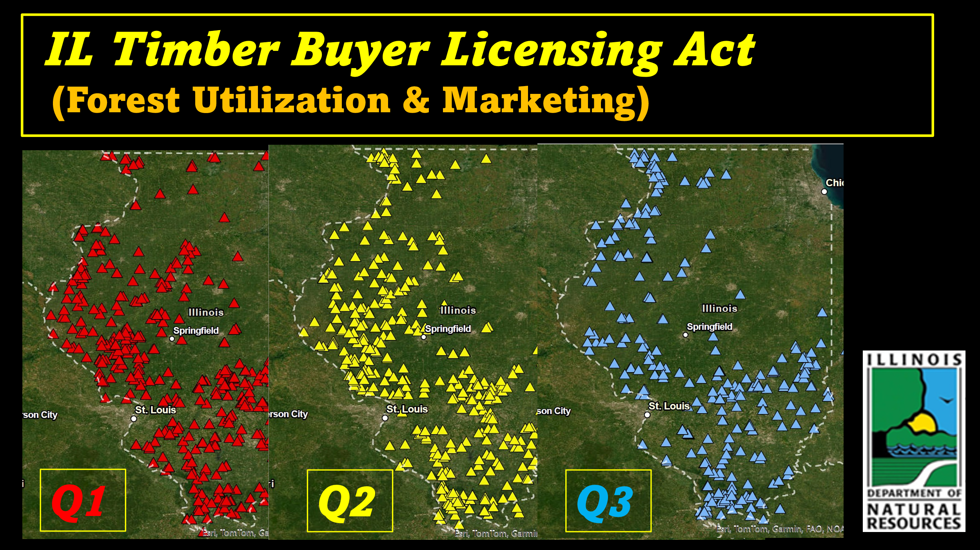

In 2024, there were a total of 233 Active Timber Buyers licensed in the state, a total of 2,699 harvests reported, and just under 50 Million Board Feet harvested. The average reported harvest value in 2024 was $20,644.

Additionally, the IDNR publishes a quarterly summary of timber prices across the state that is available for both Timber Buyers and Timber Growers (woodland owners) to refer to. The intention is to help woodland owners understand current market prices for their timber. This Report shows low, high, and average prices paid for stumpage and veneer quality logs for approximately 20 of the most common commercial timber species across the state. The IDNR also publishes an online newsletter, called “Wooden Dollars,” which provides forest industry information, timber sale announcements, Key Price Indicators, and other timely forest marketing information. Finally, a new landowner information sheet, entitled “Timber Sales Do’s and Don’ts,” was created and posted to the IDNR Forestry Division’s website.

Purpose 5. Other programs beneficial to advancing forests and forestry in the state.
While the information provided above covers the primary activities related to the IDNR Forestry Division’s activities connected to fulfilling the Forest Development Act, the Forestry Division also implements other major programmatic areas, including a very active Urban and Community Forestry Program, a Forest Health Program, a Wildfire Management and Protection Program, including the accomplishment of over 20,000 acres of controlled burns for habitat enhancement on an annual basis, the coordination of forest management activities on the State Forest system, and various Forest Conservation Educational activities. Data for these programmatic activities is beyond the scope of this Report, and they are funded through dedicated federal funds for these program areas, but all of these efforts collectively serve to advance forests and forestry in the state for the multiple benefits that all citizens of the state receive from the states forest resources.

Report respectively submitted by
Kenneth Jolly, IDNR Forestry Division Chief / State Forester

