

December 14th, 2018

Honorable Tim Anderson

Secretary of the Senate
Illinois Senate
Capitol Building Room 401
Springfield, IL 62706-1150

Honorable Timothy D. Mapes

Clerk of the House
House of Representatives
Capitol Building Room 300
Springfield, IL 62706-1150

Dear Mr. Anderson & Mr. Mapes:

In accordance with the Personal Information Protection Act (the “Act”), Southern Illinois University HealthCare (“SIU Physicians and Surgeons”) is submitting notice to the Attorney General regarding a recent breach of personal information, as defined by the Act.

On December 12th, 2018, SIU HealthCare’s Privacy Office was informed by one of our department’s that a document with personal identifiers of one patient had been inadvertently faxed to another entity. Current investigation revealed that a previous fax number remained in the que and was used to send this document.

Notification:
SIU HealthCare will notify the affected individual in writing of the breach by December 17th, 2018. This individual’s written notice will contain details of the event as well as information regarding identity theft, credit reporting agencies, and the Federal Trade Commission, pursuant to the Act.

Corrective Measures:
The Privacy Office will be providing additional awareness for all staff as to the proper faxing precautions and avoidance of sending documents with personal information to better ensure the privacy and security of our patients’ information.

If you have any questions regarding this notice, please feel free to contact me. SIU HealthCare considers the protection of personal information a high priority and will continue to work toward making all of its operations as secure as possible.

Sincerely,

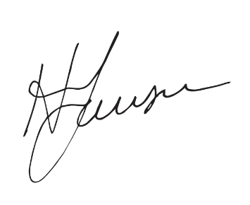
Harald Lausen, DO, MA
Chief Medical Officer and HIPAA Privacy Officer
SIU School of Medicine

